

COLEG GWYDDONIAETH A PHEIRIANNEG

COLLEGE OF SCIENCE AND ENGINEERING

**YSGOL CYFRIFIADUREG A PHEIRIANNEG**

**SCHOOL OF COMPUTER SCIENCE AND ENGINEERING**

**ASSESSMENT BRIEF**

**BRIFF ASESU**

|  |  |
| --- | --- |
| **Module Title, Code, Year** | ICE 4611 / ICE 1601 Database Systems 2023-24 |
| **Assessment Name, Length, Duration** | Basic Queries Assignment (2 weeks, plus reading week) |
| **% Contribution to Module Mark** | 10% |
| **Deadline (Date and Time) for Submission** | 13/11/2023 09:00 |
| **Format/Location of Submission** | Submit on Blackboard in the “Assessments Section” |
| **Assessment Feedback** Written feedback will be provided on Blackboard within 2 weeks of the submission deadline. | |
| **Marking Criteria** Each question is worth 10% of the mark. Marks will be awarded for:   * Writing correct SQL queries * Writing efficient SQL queries * Appropriate use of comments * Layout and presentation of the document | |
| **Referencing**The school uses the IEEE referencing style: [IEEE-Reference-Guide.pdf](https://ieeeauthorcenter.ieee.org/wp-content/uploads/IEEE-Reference-Guide.pdf) | |
| **Plagiarism & Unfair Practice**  Plagiarised work will be given a mark of zero. Remember when you submit you agree to the standard agreement: *“This piece of work is a result of my own work except where it is a group assignment for which approved collaboration has been granted. Material from the work of others (from a book, a journal or the Web) used in this assignment has been acknowledged and quotations and paraphrasing suitably indicated. I appreciate that to imply that such work is mine, could lead to a nil mark, failing the module or being excluded from the University. I also testify that no substantial part of this work has been previously submitted for assessment.”* | |
| **Late Submission & Extensions**  Work submitted within one week of the stated deadline will be marked but the mark will be capped at 40%. A mark of 0% will be awarded for any work submitted 1 week after the deadline. Extensions must be applied for using the Request Centre in MyBangor. They must be approved prior to the original deadline. | |
| **Contact for Queries**  If any further information is required regarding this assessment, please contact Andy Harbach (ees60b@bangor.ac.uk). | |
| **Detailed Assessment Guidance**  This assignment consists of ten short exercises involving the use of SQL queries. Each exercise is worth *10%*. Marks may be awarded for attempts which are not wholly correct. **Even if you are not sure of a solution it is better to write something than nothing.** Note that the exercises get progressively more difficult.  When doing assessed work, staff will not be able to give you the answer to the question. They will however assist you if you are stuck with a question (perhaps by pointing you towards some reading) so please ask if there is something you do not understand.  Use *Workbench* to develop your queries and store this work in a single SQL script file (please do not submit 10 separate files).  For each exercise check your result table against the actual data in the *DreamHome* database. The fact that your query executes does not necessarily mean that it is correct.  Also remember that just because you get the correct results displayed does not mean your query is correct – it could just be coincidence and your query may not work if there were additional valid data in the database.  Your SQL script should:   * contain appropriately formatted queries. * contain comments to indicate the question numbers. * follow a consistent style of indentation. * capitalise all reserved words, or at least be consistent.   This assessment maps to the following learning outcomes for the module:   * Use SQL to query a database | |
| **Prepared by:** Andy Harbach  **Date Last Updated:** 17/10/23 | |

# Exercise 1: Selecting Rows (10%)

Write a query to get all details relating to staff who are *either* assistants *or* supervisors.

# Exercise 2: Selecting Rows and Columns (10%)

Write a query to list the property number, address, type, number of rooms, and rent for all rental properties assigned to branch B003.

# Exercise 3: Matching Strings (10%)

Write a query to list all the details of private owners who have a Glasgow address.

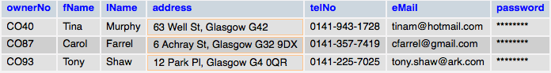

# Exercise 4: Listing Clients (10%)

Write a query to list the clients who have viewed one or more properties. Clients should be listed by client number only and the result table should contain *no* *duplicates*.

# Exercise 5: Calculated Columns (10%)

Write a query to display all details of rental properties. The column containing the figure for rent should contain the yearly rent and should be labelled as ‘yearly rent’. Thus the yearly rent for property PL94 should be £4,800. Use an appropriate function to prefix the rent with a ‘£’ symbol. Your output should resemble the following:

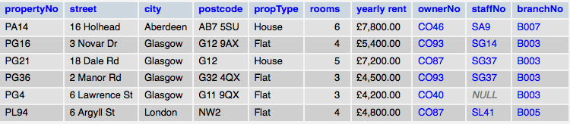

# Exercise 6: Using ORDER BY (10%)

Write a query to list all details of viewings where a comment has been provided. The result table should be ordered by date (major sort key) in descending order, then client number (minor sort key) in ascending order.

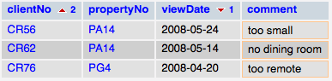

# Exercise 7: Aggregate Functions (10%)

Write a query to list the minimum, average and maximum number of rooms for all properties available to rent. The average figure should be rounded to one decimal place. Re-name columns as illustrated below:

Example output for exercise 7.

# Exercise 8: Oldest and Youngest (10%)

Write a query to find the birthdays of the youngest and oldest members of staff. The results must be displayed on one line with column headings Oldest and Youngest and only the dates shown.

# Exercise 9: Grouping Data (10%)

Write a query to list how many properties, registered with *DreamHome* for rent have either 3, 4, or 5 rooms. As illustrated below, the result table should display the averagerent for *each* *category* of property. When writing your query think about what would happen if the requirement changes to be 3,4,5,6,7,8,9 or 10 rooms.

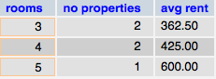

# Exercise 10:Grouping Data (10%)

For each branch, get a listing of how many properties registered at that branch are owned by each client.

Modify your solution so that the listing contains *only* those clients who have more than one property registered at a specific branch.

Example output for exercise 10.